PrismHR Software

Complete HR software combined with our expert HR services for all your
payroll, benefits, compliance and HR needs.

PrismHR is a web-based platform that centralizes administrative tasks and provides visibility into your workforce. All of your employees’ data is accessible at any time from any device, securely, using multi-factor authentication. All modules, from employee onboarding to benefits enrollment, are seamlessly integrated - meaning data automatically flows from one process to the next without any need to rekey data.
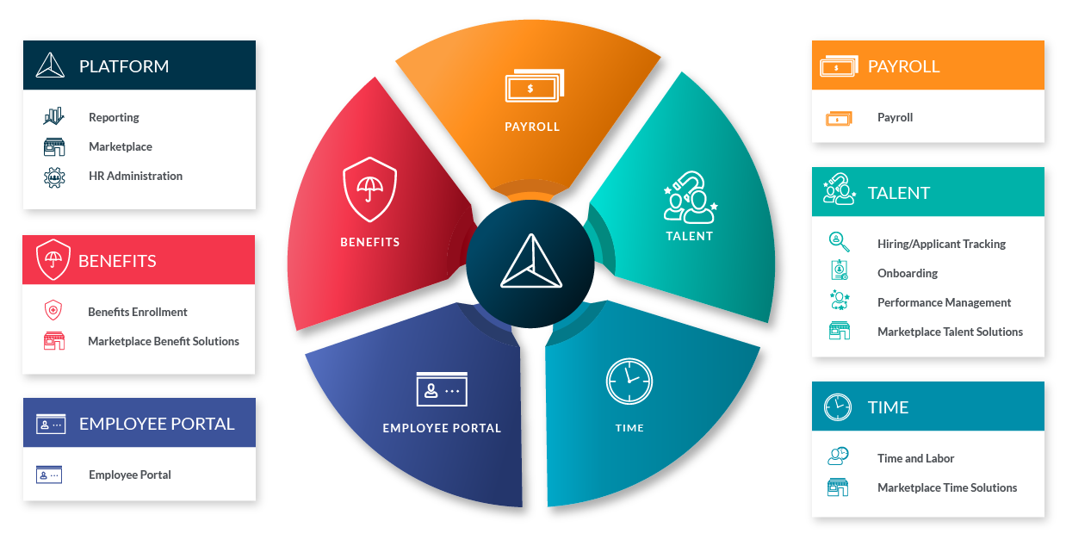

Proven Solution for:

80,000+ Organizations | 2,000,000+ Employees |   $80+ Billion  in Annual Payroll

